**1) Find all branch names and cities with assets more than 1000000. (on single table)**

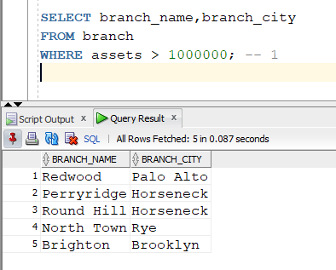

**2) Find all account numbers and their balance which are opened in ‘Downtown’ branch or which have balance in between 600 and 750. (on single table)**

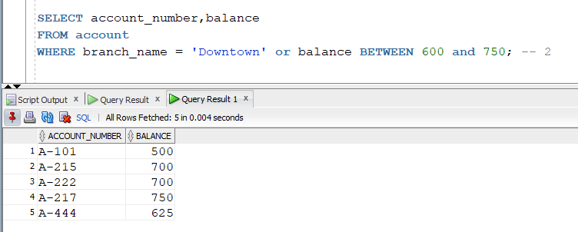

**3) Find all account numbers which are opened in a branch located in ‘Rye’ city. (multiple tables)**

**4) Find all loan numbers which have amount greater than or equal to 1000 and their customers are living in ‘Harrison’ city. (multiple tables)**

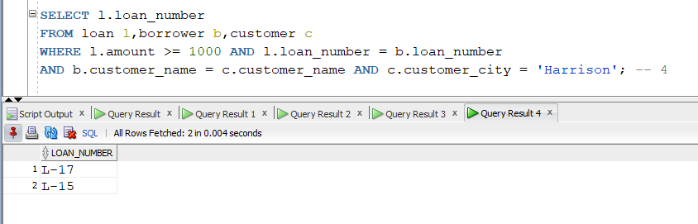

**5) Display the account related information based on the descending order of the balance. (order by clause)**

**6) Display the customer related information in alphabetic order of customer cities. (order by clause)**

**7) Find all customer names who have an account as well as a loan. (intersect)**

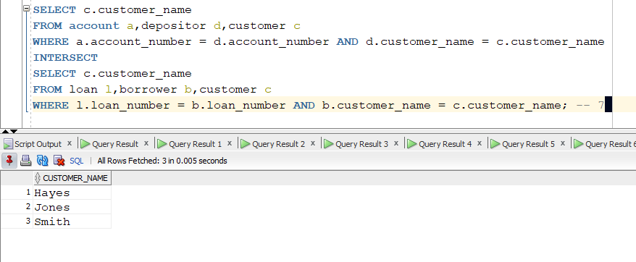

**8) Find all customer related information who have an account or a loan. (union)**

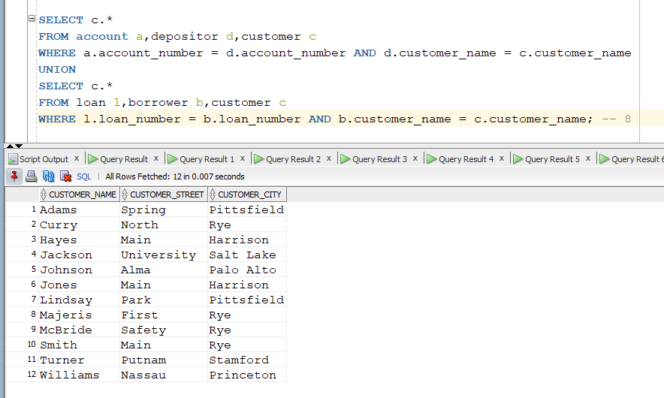

**9) Find all customer names and their cities who have a loan but not an account. (minus)**

**10) Find the total assets of all branches. (aggregate function)**

**11) Find the average balance of accounts at each branch. (aggregate function)**

**12) Find the average balance of accounts at each branch city. (aggregate function)**

**13) Find the lowest amount of loan at each branch. (aggregate function)**

**14) Find the total number of loans at each branch. (aggregate function)**

**15) Find the customer name and account number of the account which has the highest balance. (aggregate function)**

